Silhouette metric for img011001.jpg is: 0.1141564918969353

Davies Bouldin metric for img011001.jpg is: 5.189090601090551

Calinski Harabasz metric for img011001.jpg is: 4.07277373056416

ID 0: (1737, 445)

ID 1: (1735, 446)

ID 2: (1737, 444)

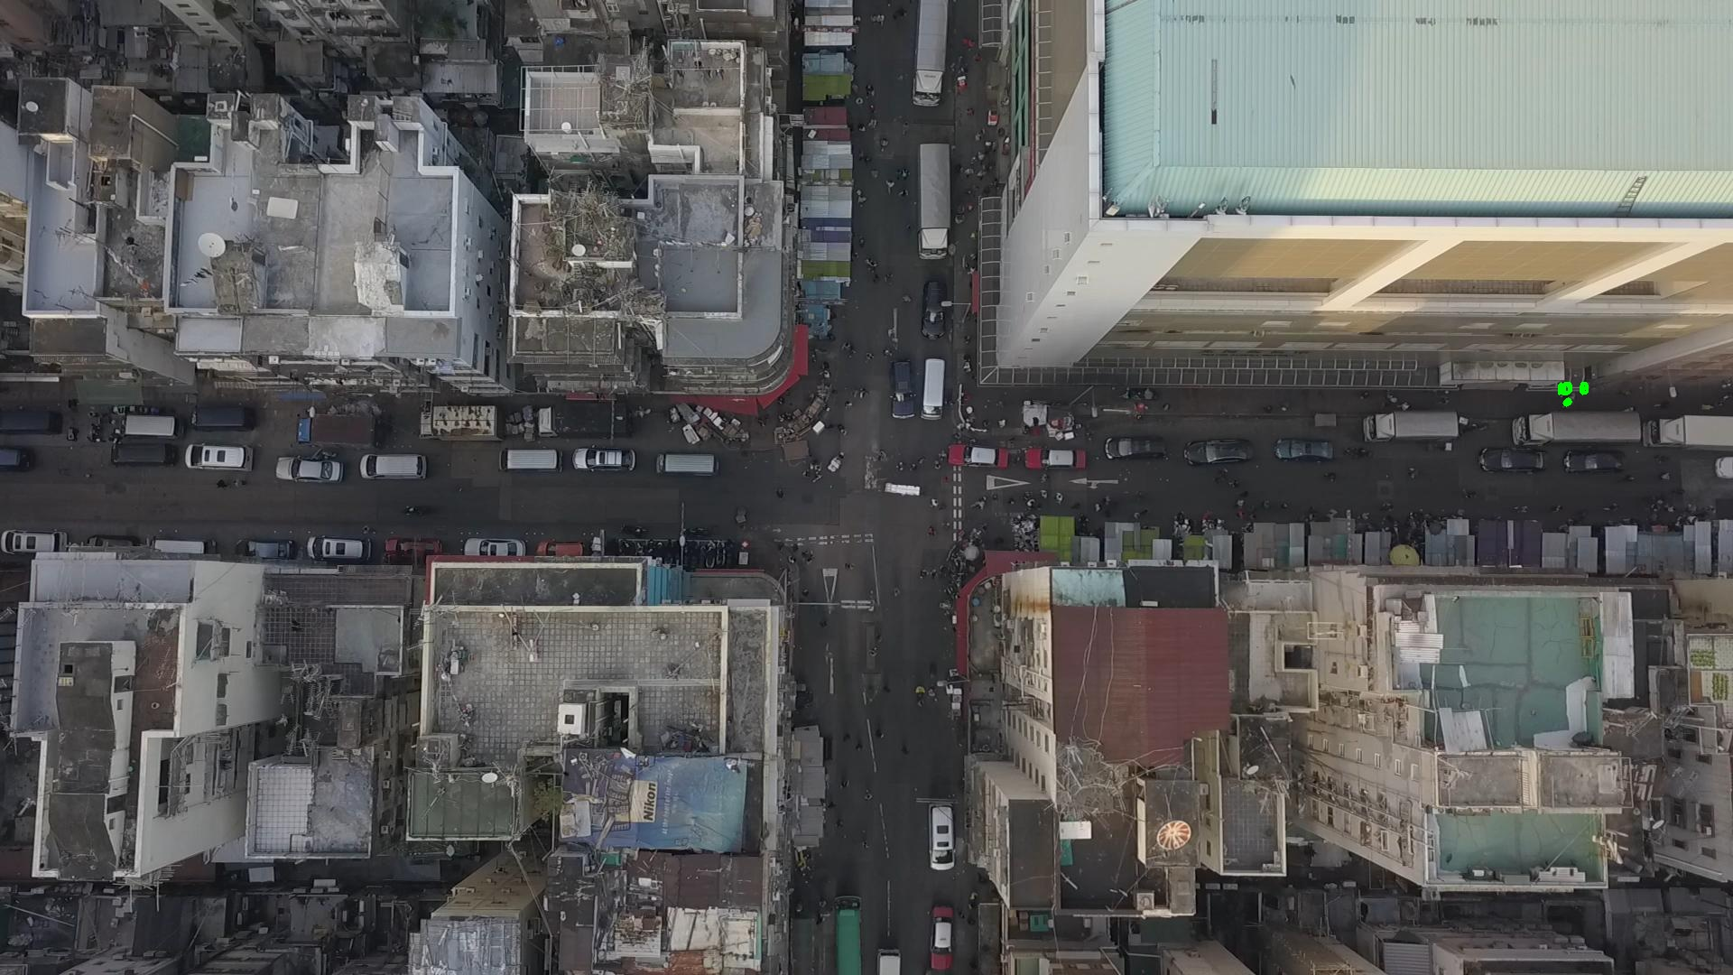

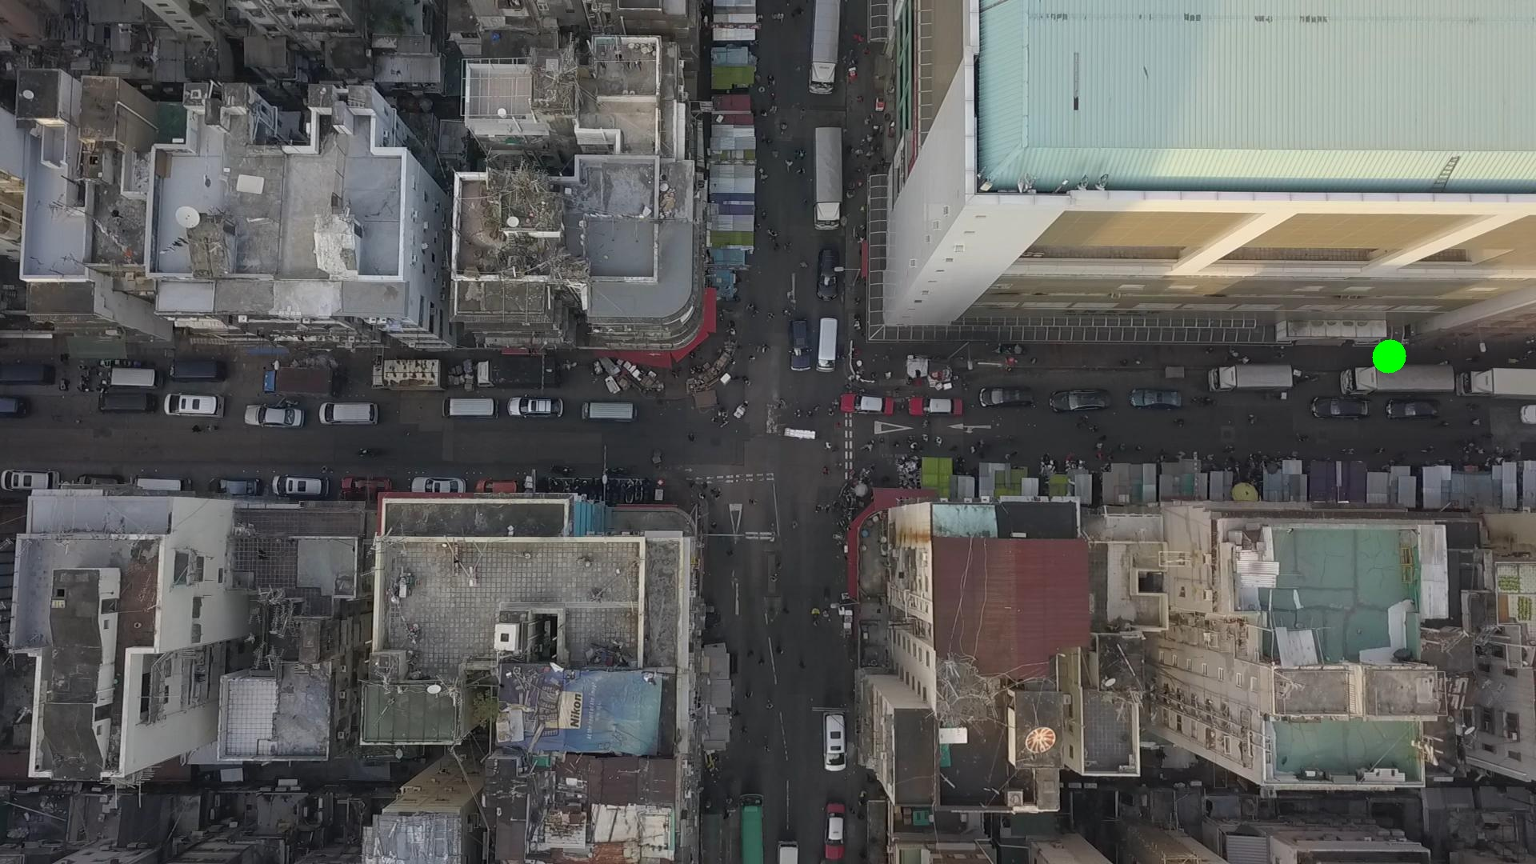

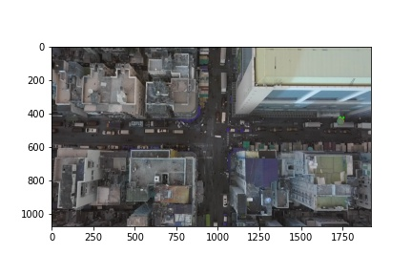

Silhouette metric for img011002.jpg is: 0.2670814846872951

Davies Bouldin metric for img011002.jpg is: 5.00681906690319

Calinski Harabasz metric for img011002.jpg is: 28.46745332354409

ID 0: (1737, 445)

ID 1: (1089, 181)

ID 2: (1737, 444)

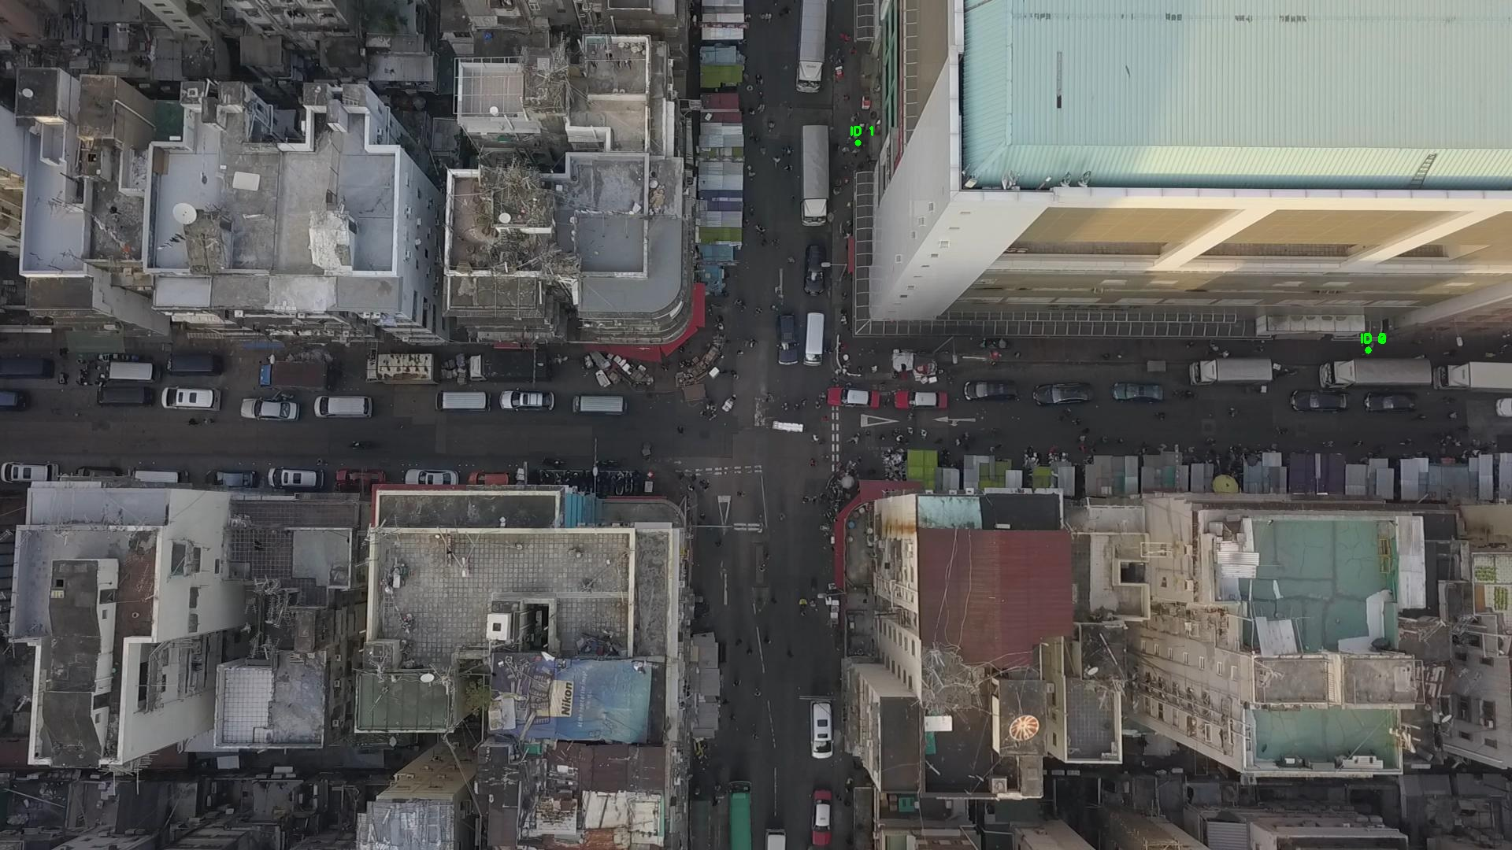

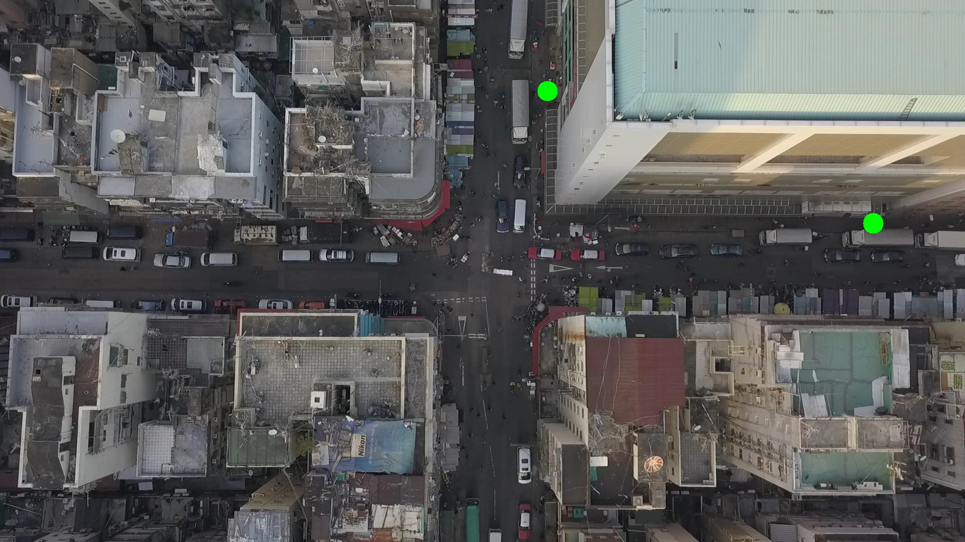

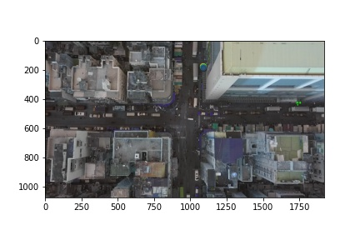

Silhouette metric for img011003.jpg is: 0.30355008178373044

Davies Bouldin metric for img011003.jpg is: 2.8864737951243917

Calinski Harabasz metric for img011003.jpg is: 35.43528655513098

ID 0: (1737, 445)

ID 1: (1089, 181)

ID 2: (1089, 183)

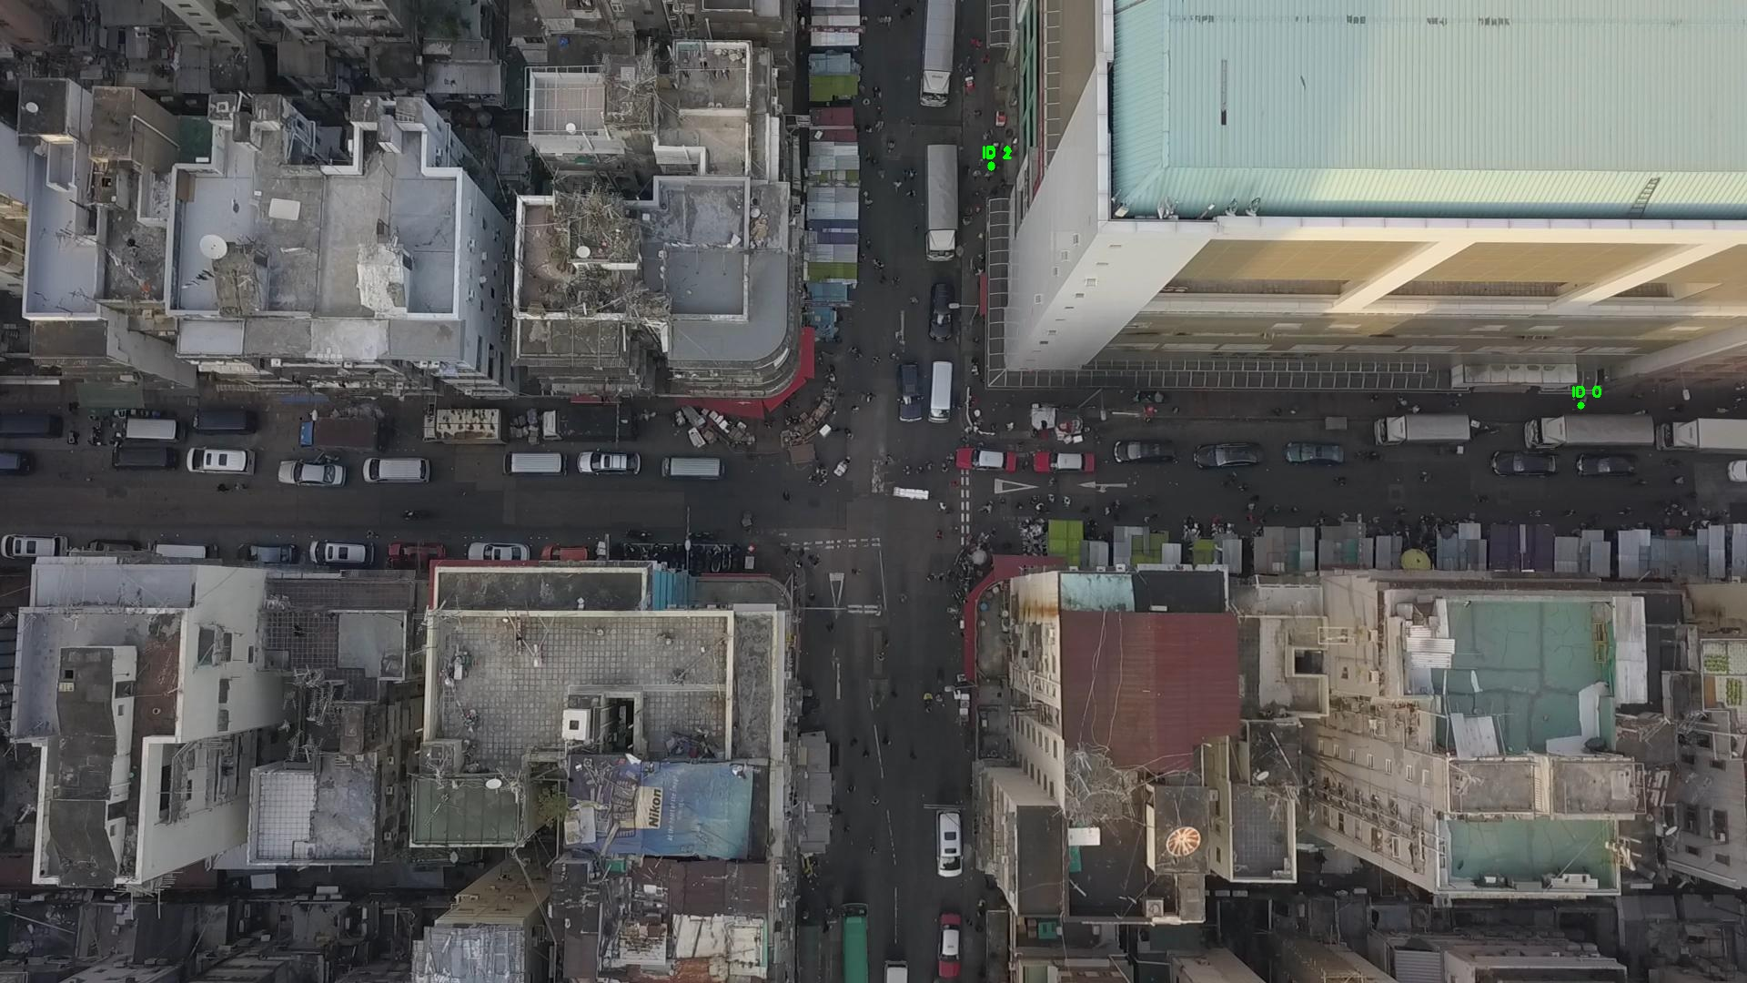

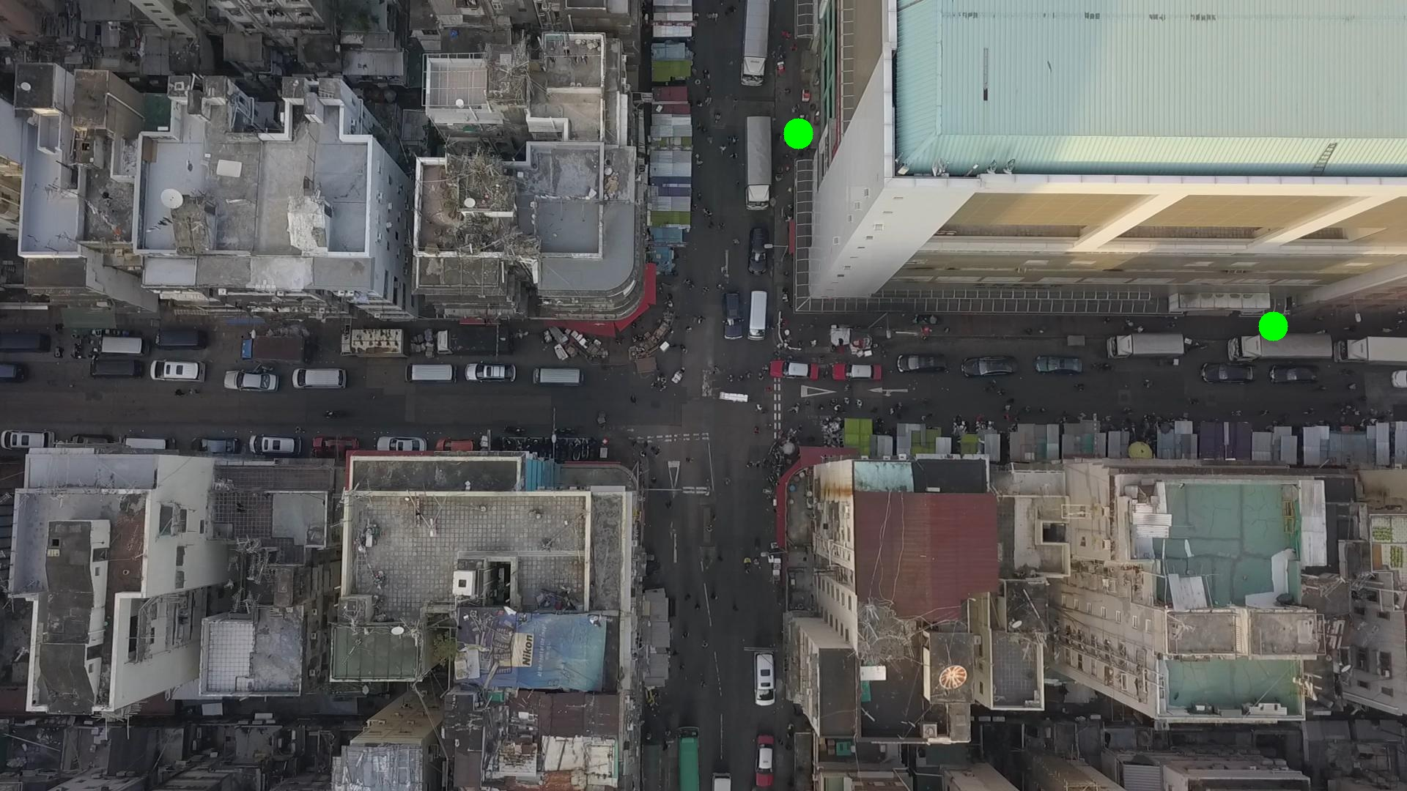

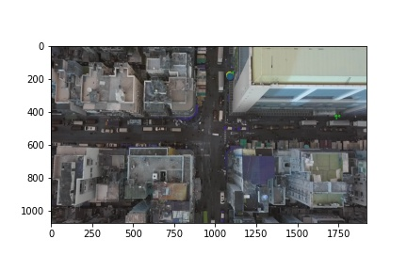

HDBSCAN cannot be performed on img011004.h5 with bg_tresh: 0.75

Metrics are not computable for img011004.jpg with bg_tresh: 0.75

ID 0: (1737, 445)

ID 1: (1089, 181)

ID 2: (1089, 183)

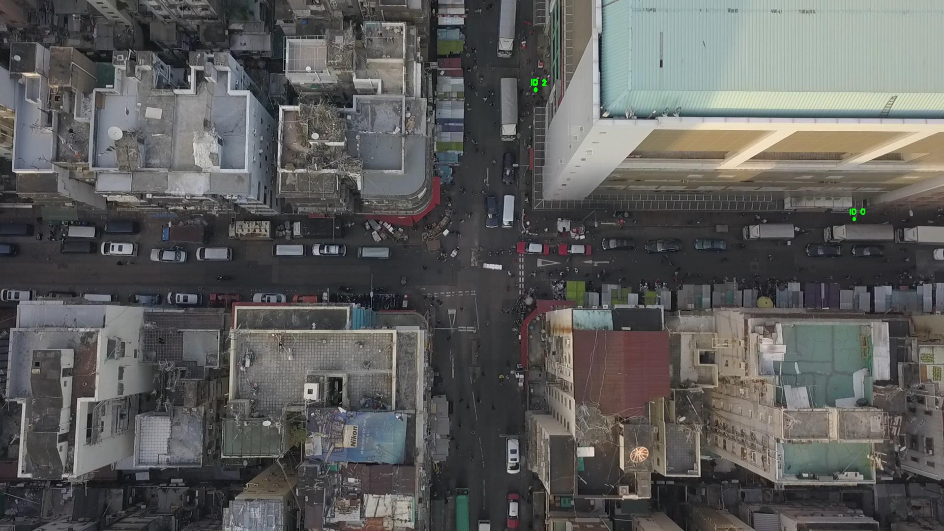

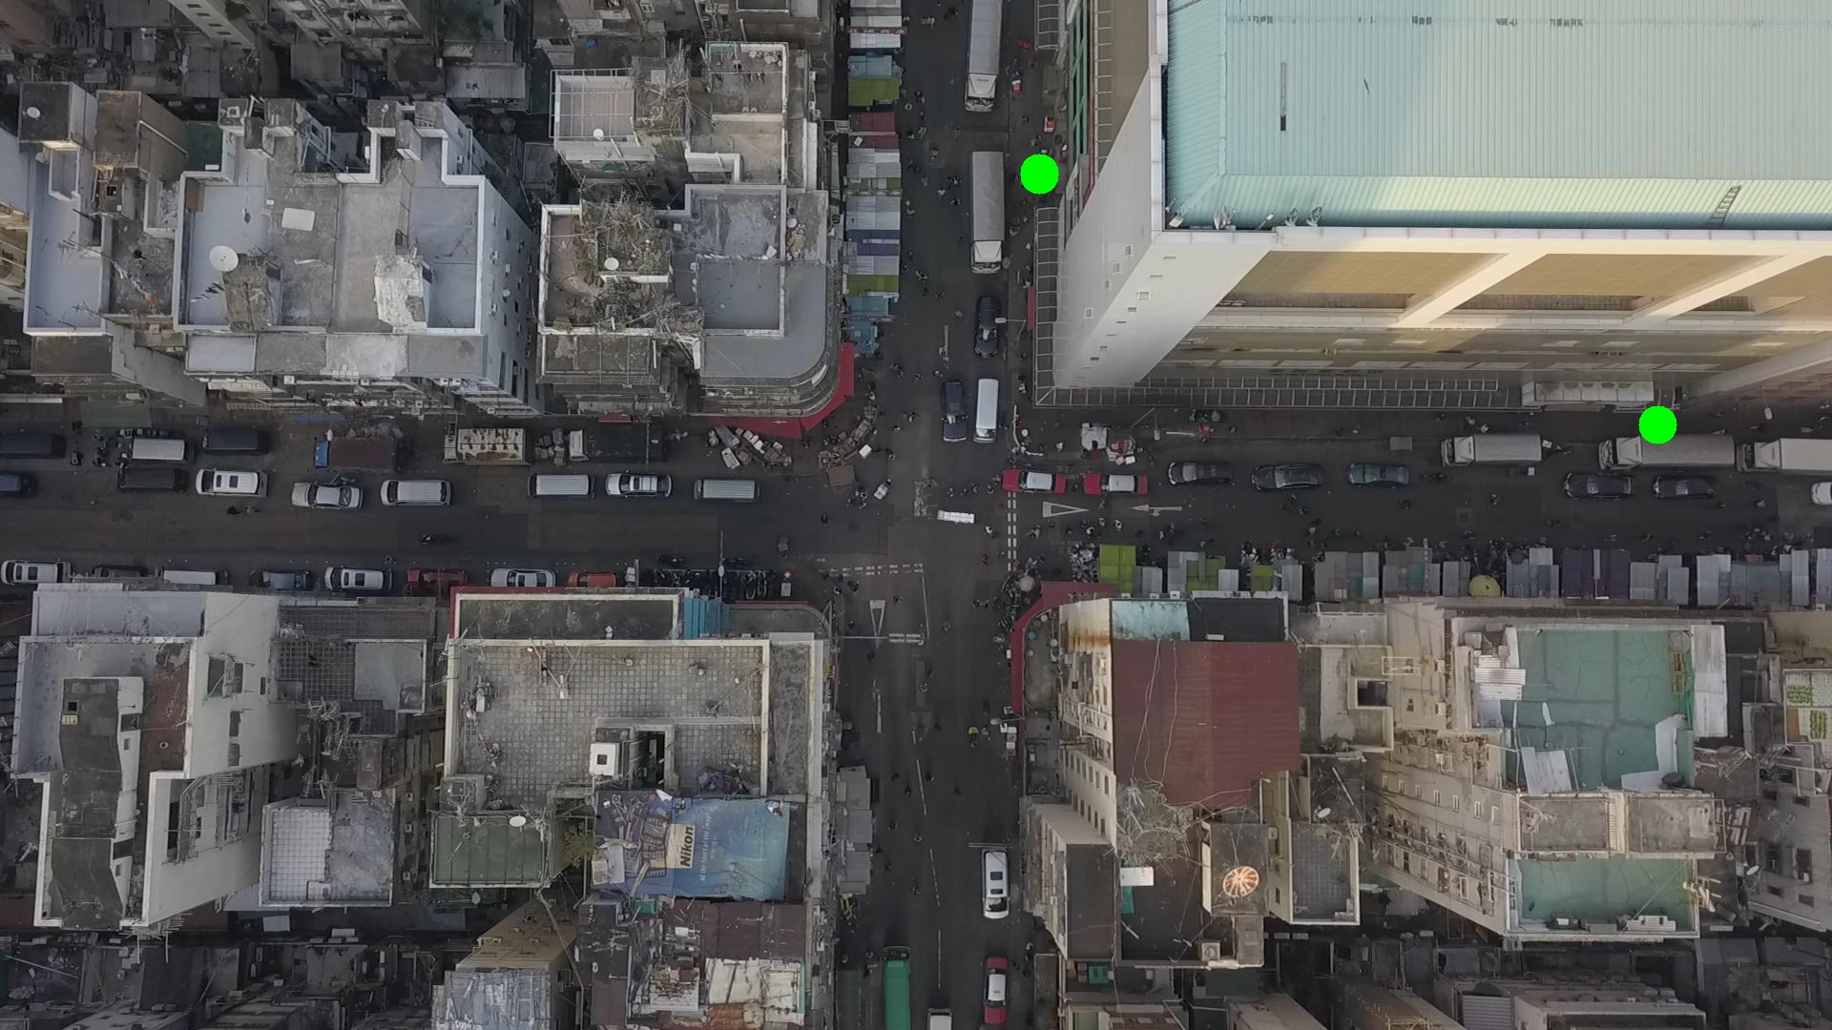

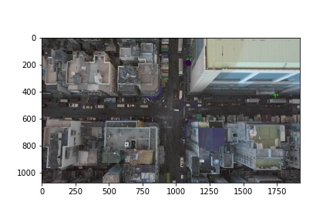

Silhouette metric for img011005.jpg is: -0.04663063082981405

Davies Bouldin metric for img011005.jpg is: 1.7468398826382046

Calinski Harabasz metric for img011005.jpg is: 4.993869305713079

ID 0: (1093, 230)

ID 1: (1086, 180)

ID 2: (1089, 183)

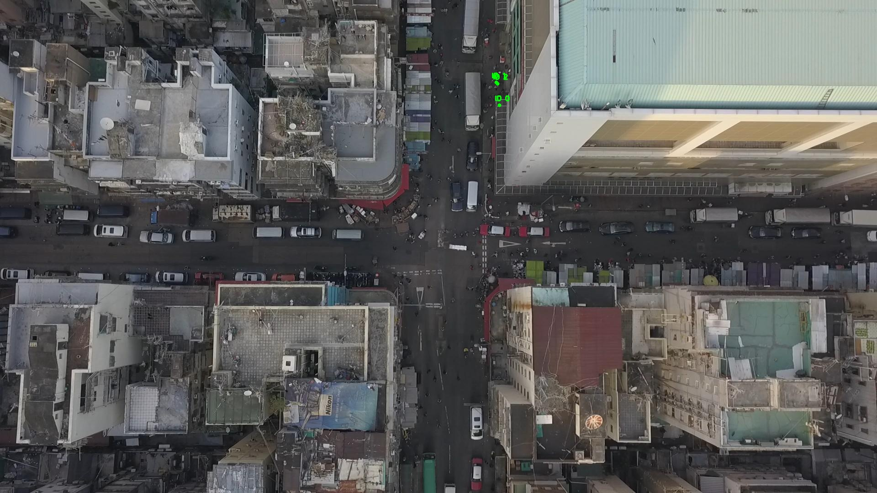

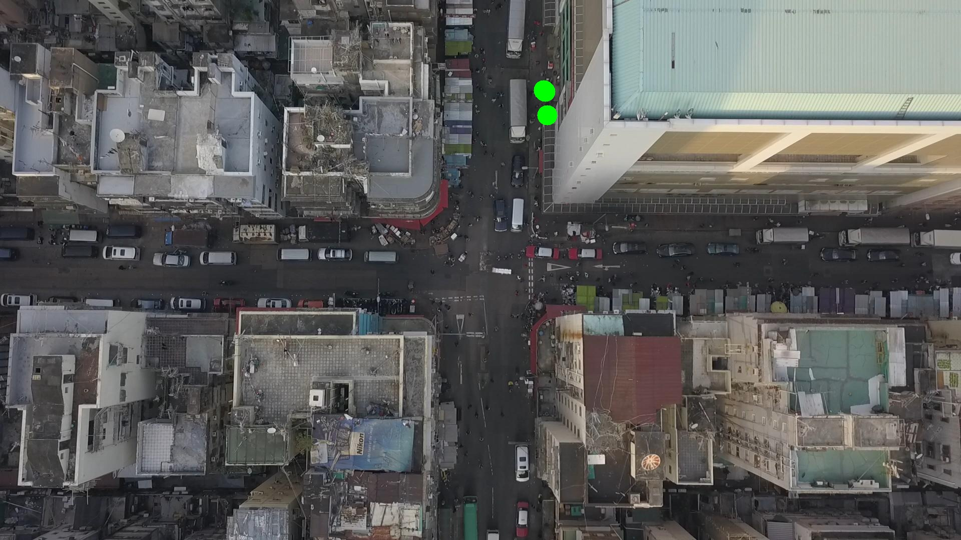

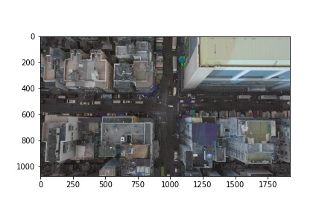

Silhouette metric for img011006.jpg is: 0.8291626773867938

Davies Bouldin metric for img011006.jpg is: 0.17575822955874773

Calinski Harabasz metric for img011006.jpg is: 2974.3445892780906

ID 0: (1093, 230)

ID 1: (1086, 180)

ID 2: (1085, 190)

ID 3: (890, 654)

ID 4: (1376, 553)

ID 5: (1142, 558)

ID 6: (905, 421)

ID 7: (966, 289)

ID 8: (1000, 191)

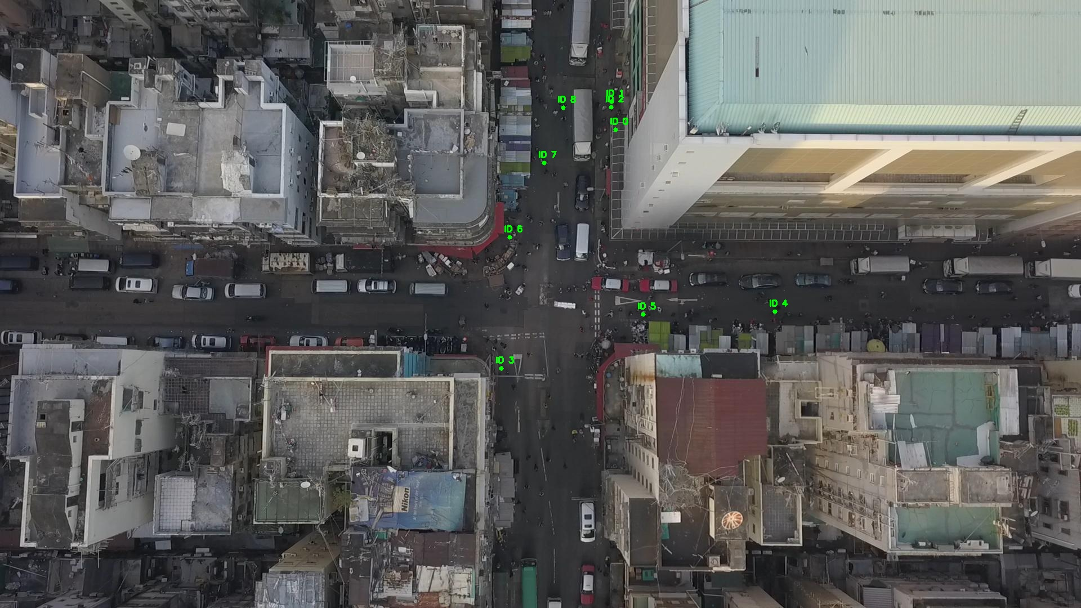

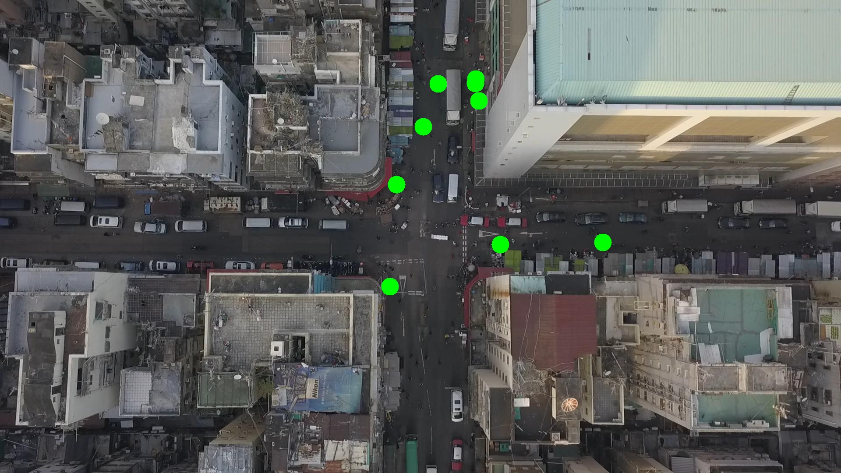

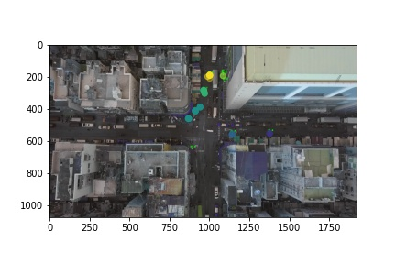

Silhouette metric for img011007.jpg is: 0.8726483585361456

Davies Bouldin metric for img011007.jpg is: 0.12367015539452804

Calinski Harabasz metric for img011007.jpg is: 7870.619849883097

ID 0: (1093, 230)

ID 1: (1086, 180)

ID 2: (1085, 190)

ID 3: (891, 653)

ID 4: (1376, 553)

ID 5: (1142, 558)

ID 6: (925, 387)

ID 7: (965, 285)

ID 8: (1000, 191)

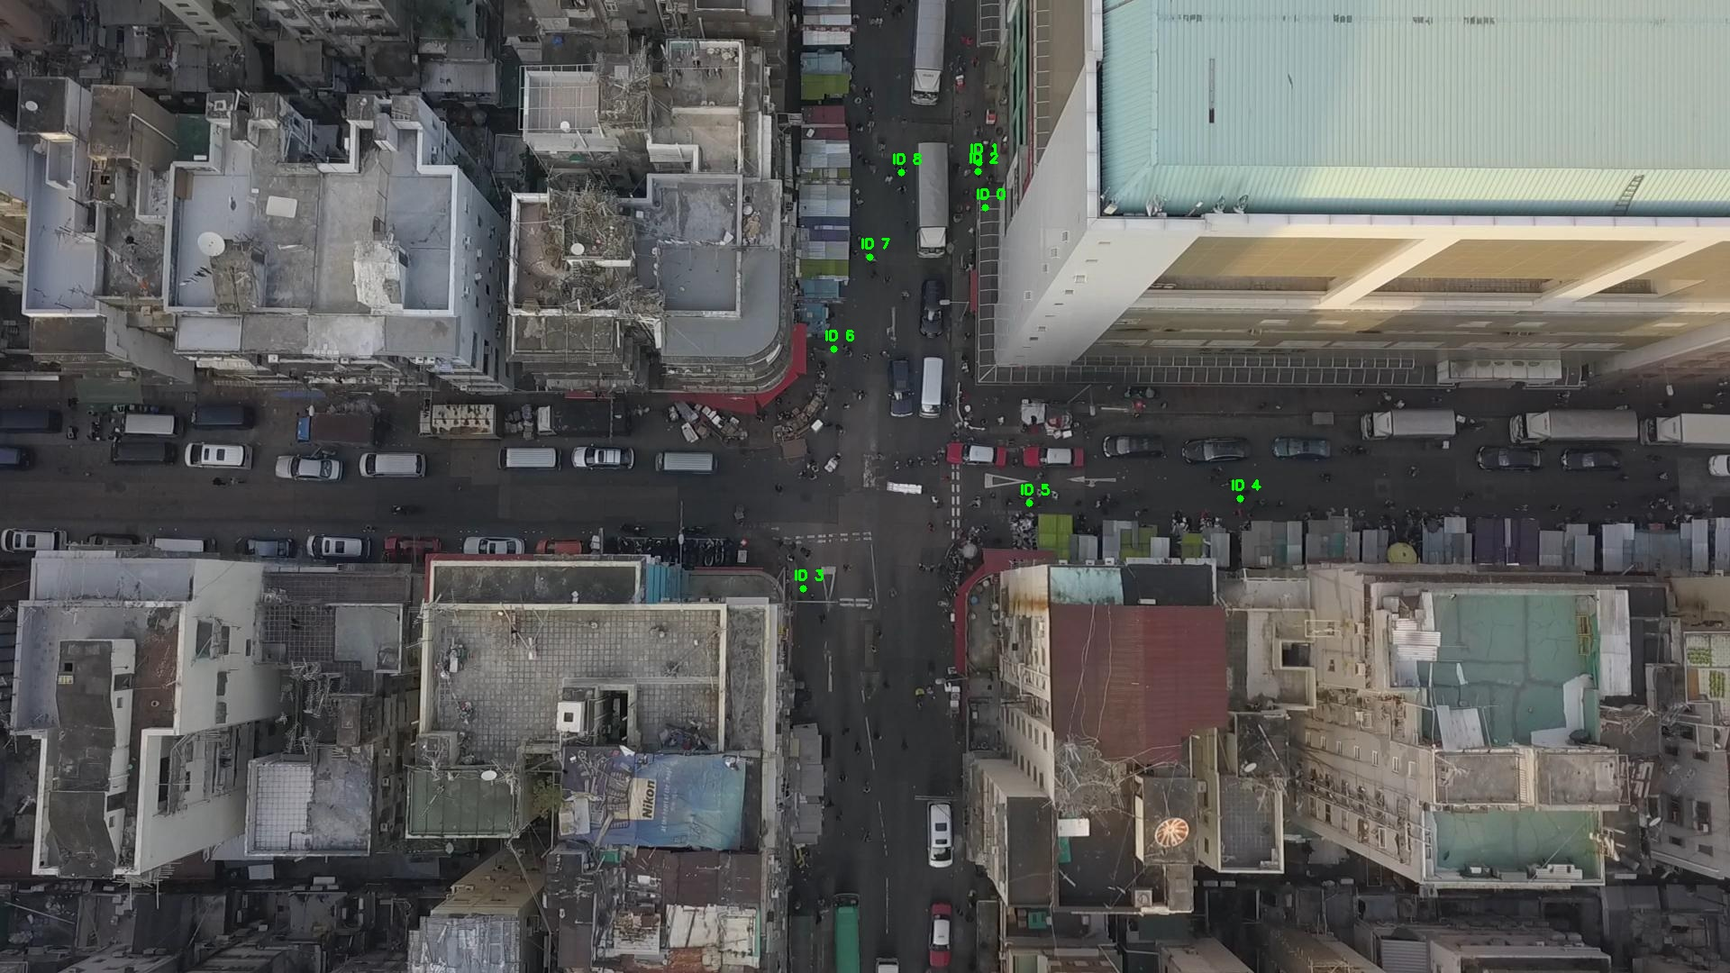

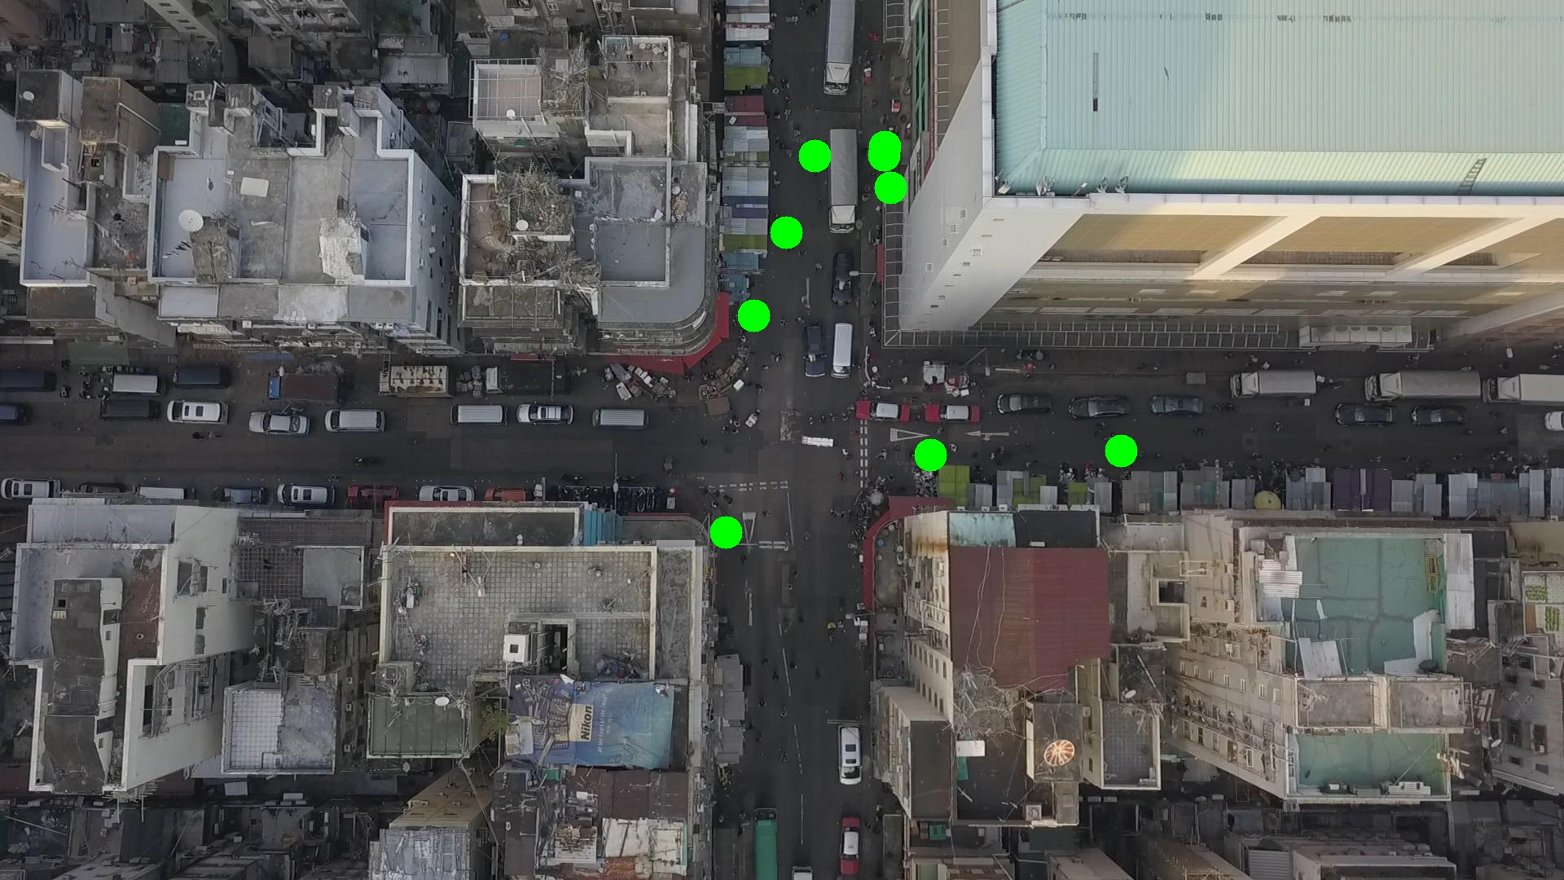

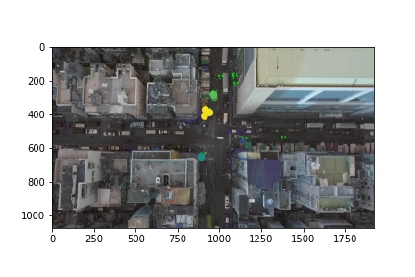

Silhouette metric for img011008.jpg is: 0.9414578095245563

Davies Bouldin metric for img011008.jpg is: 0.06689673142595538

Calinski Harabasz metric for img011008.jpg is: 34959.10554243018

ID 0: (1093, 230)

ID 1: (1082, 179)

ID 2: (1085, 190)

ID 3: (891, 653)

ID 4: (1376, 553)

ID 5: (1138, 560)

ID 6: (936, 385)

ID 7: (966, 284)

ID 8: (1000, 191)

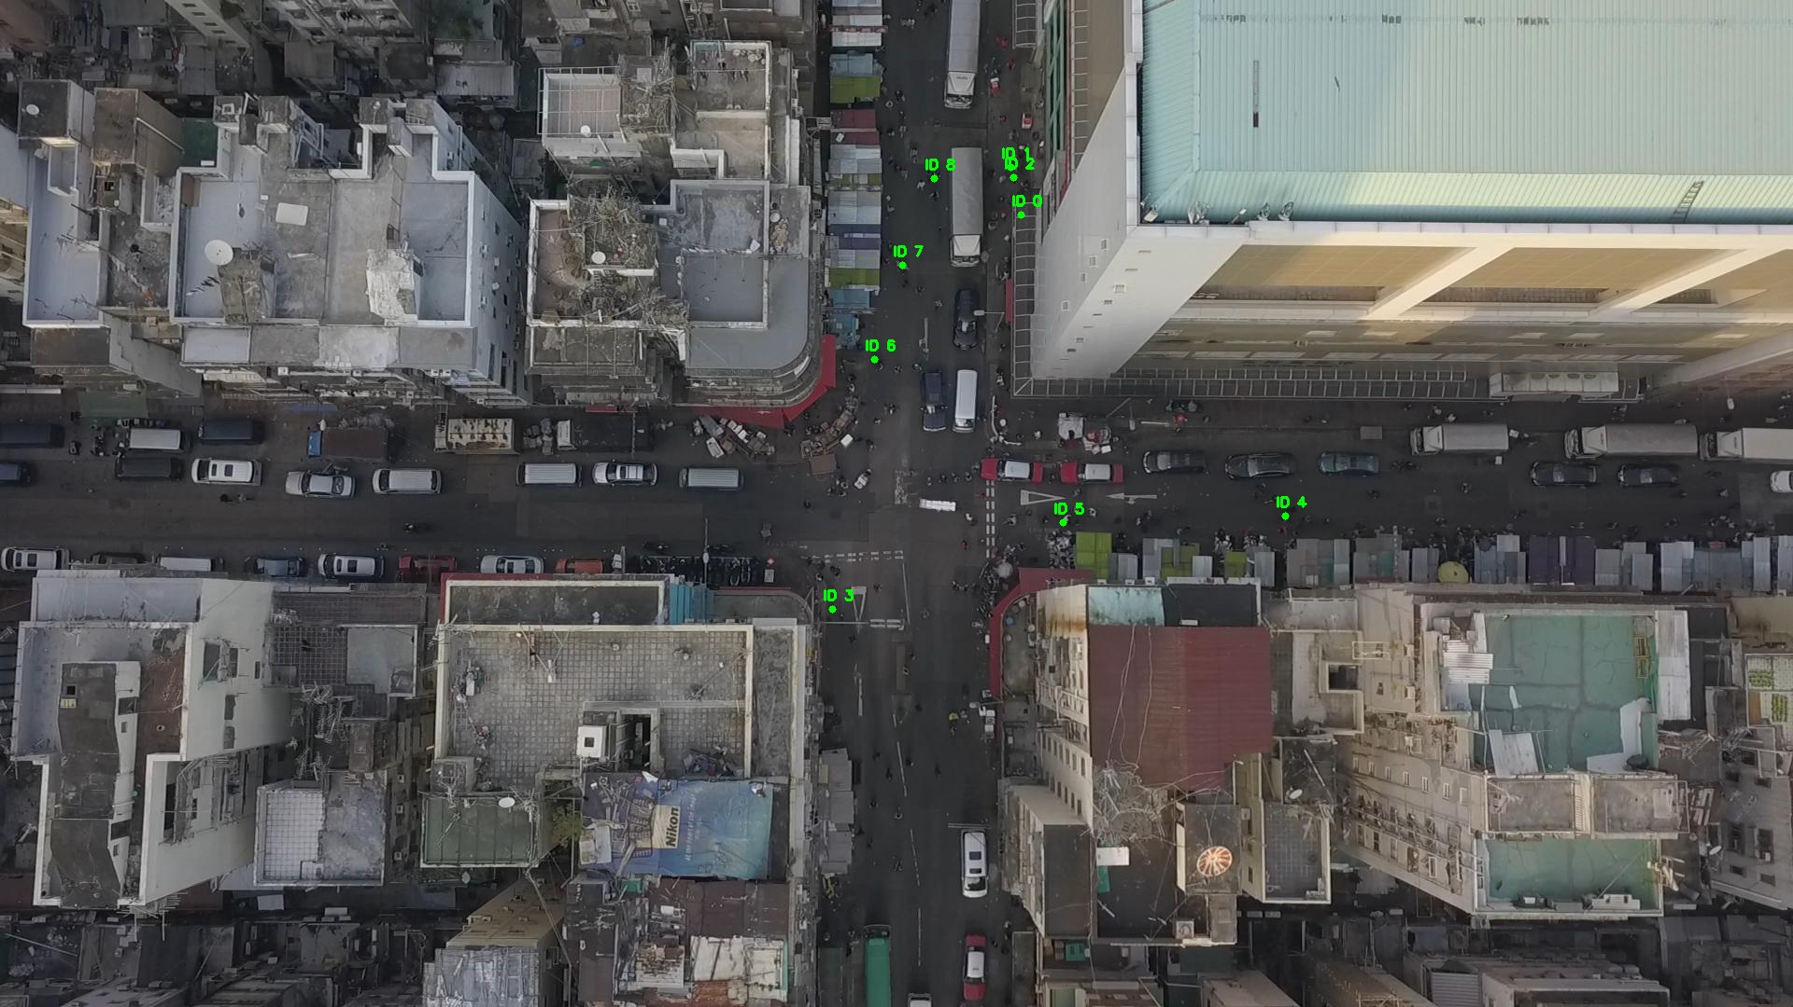

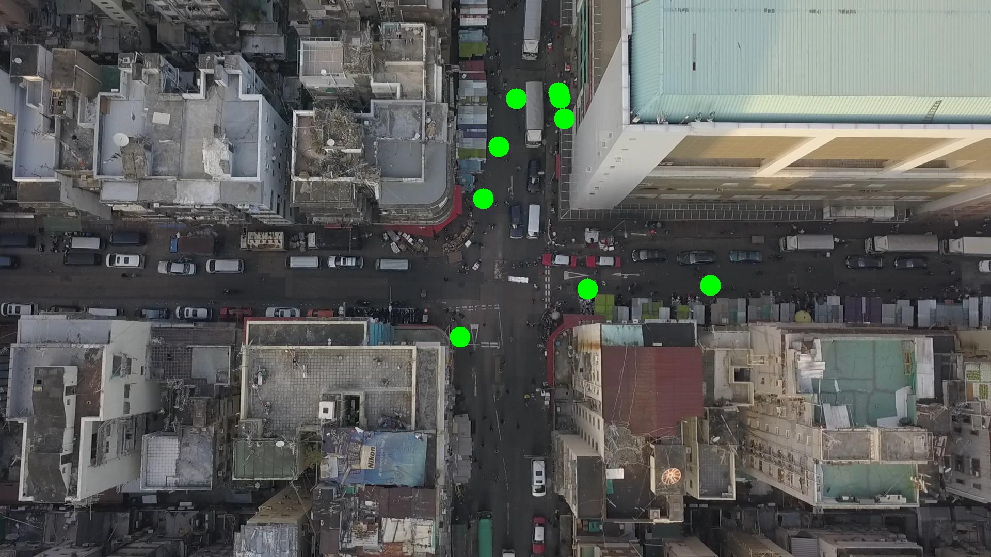

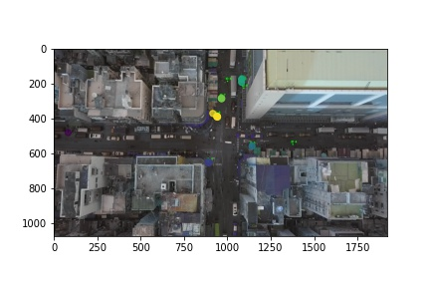

Silhouette metric for img011009.jpg is: 0.9206152628989183

Davies Bouldin metric for img011009.jpg is: 0.10427910445380374

Calinski Harabasz metric for img011009.jpg is: 34388.763468359444

ID 0: (1093, 230)

ID 1: (1082, 179)

ID 2: (1085, 190)

ID 3: (891, 653)

ID 4: (1376, 553)

ID 5: (1142, 580)

ID 6: (935, 390)

ID 7: (966, 287)

ID 8: (1000, 191)

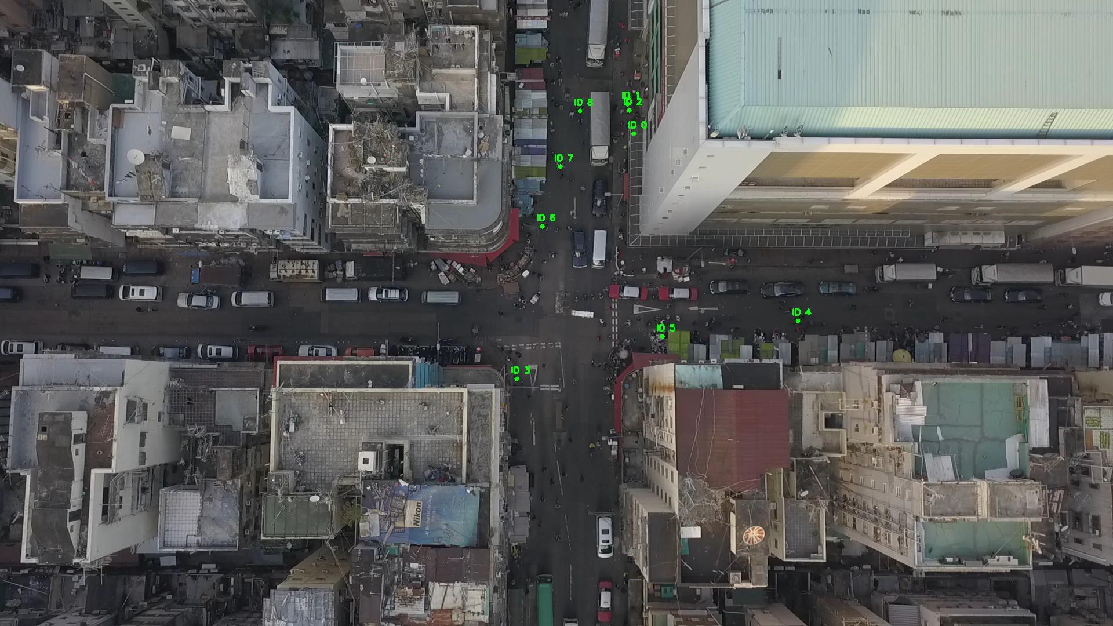

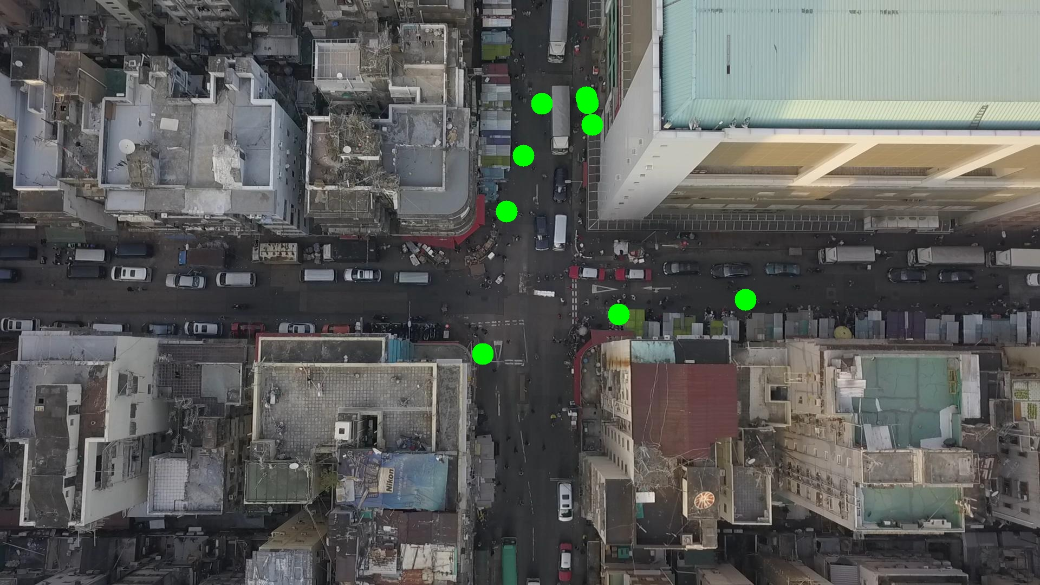

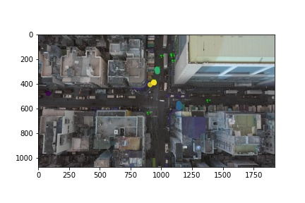

Silhouette metric for img011010.jpg is: 0.9493915074103642

Davies Bouldin metric for img011010.jpg is: 0.05843399897439597

Calinski Harabasz metric for img011010.jpg is: 17779.82277976614

ID 0: (1093, 230)

ID 1: (1082, 179)

ID 2: (1085, 190)

ID 3: (891, 653)

ID 4: (1376, 553)

ID 5: (1140, 572)

ID 6: (939, 389)

ID 7: (966, 287)

ID 8: (1000, 191)

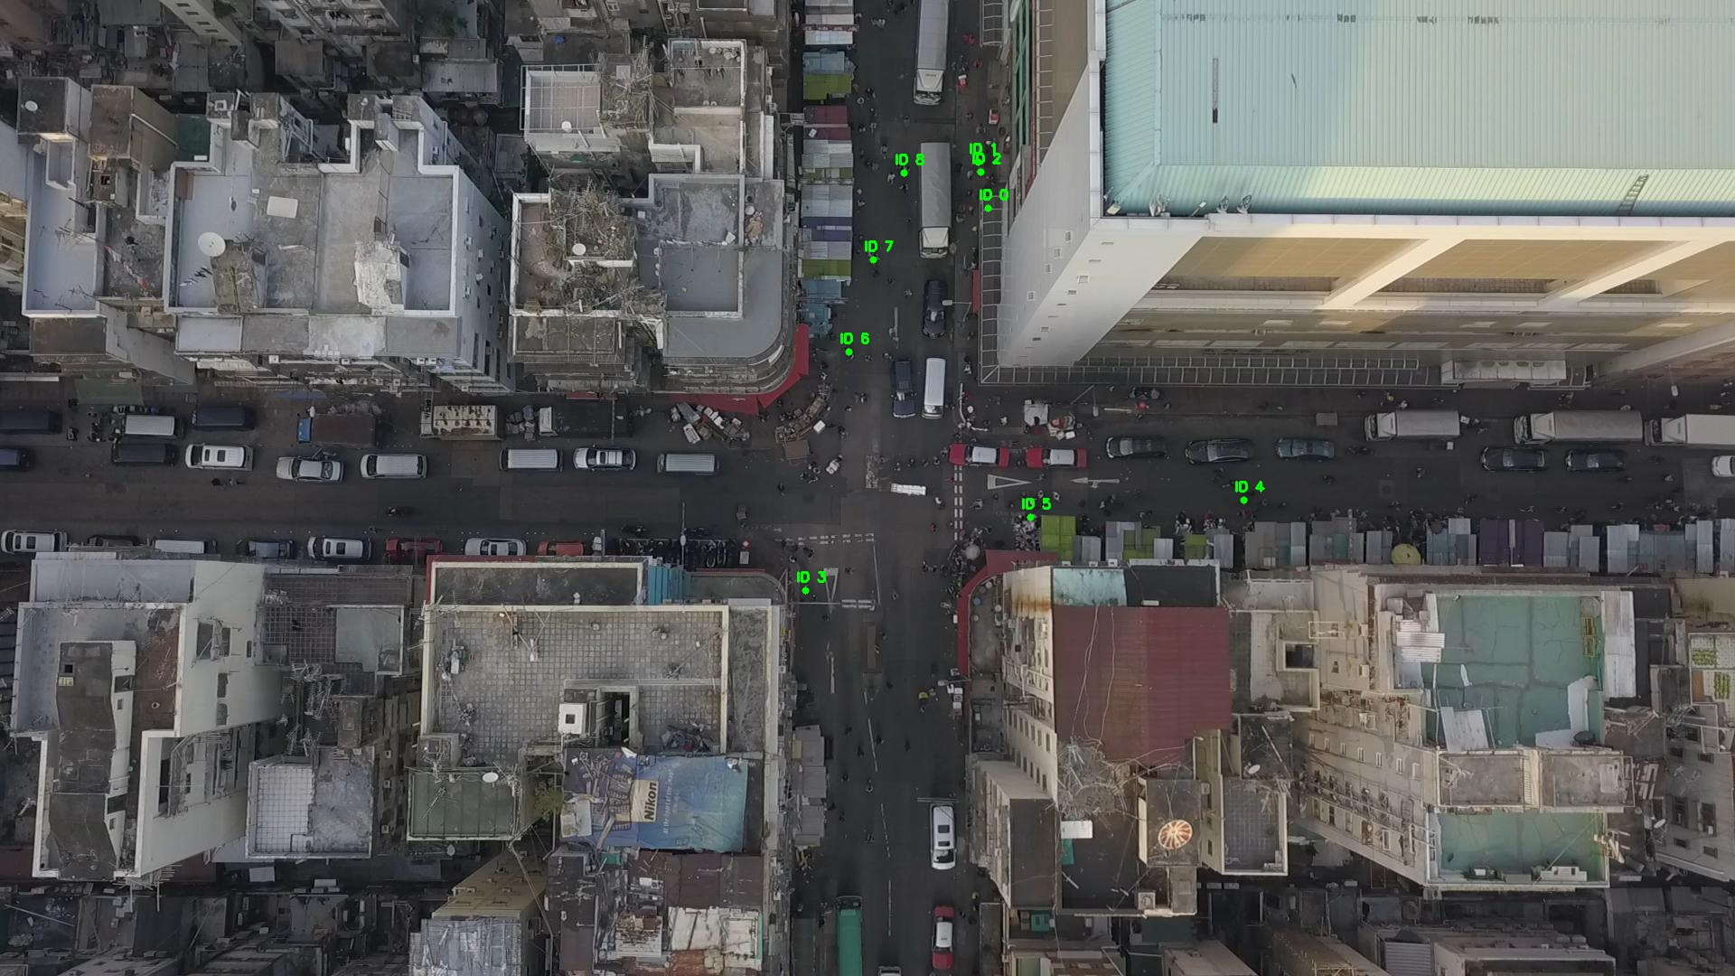

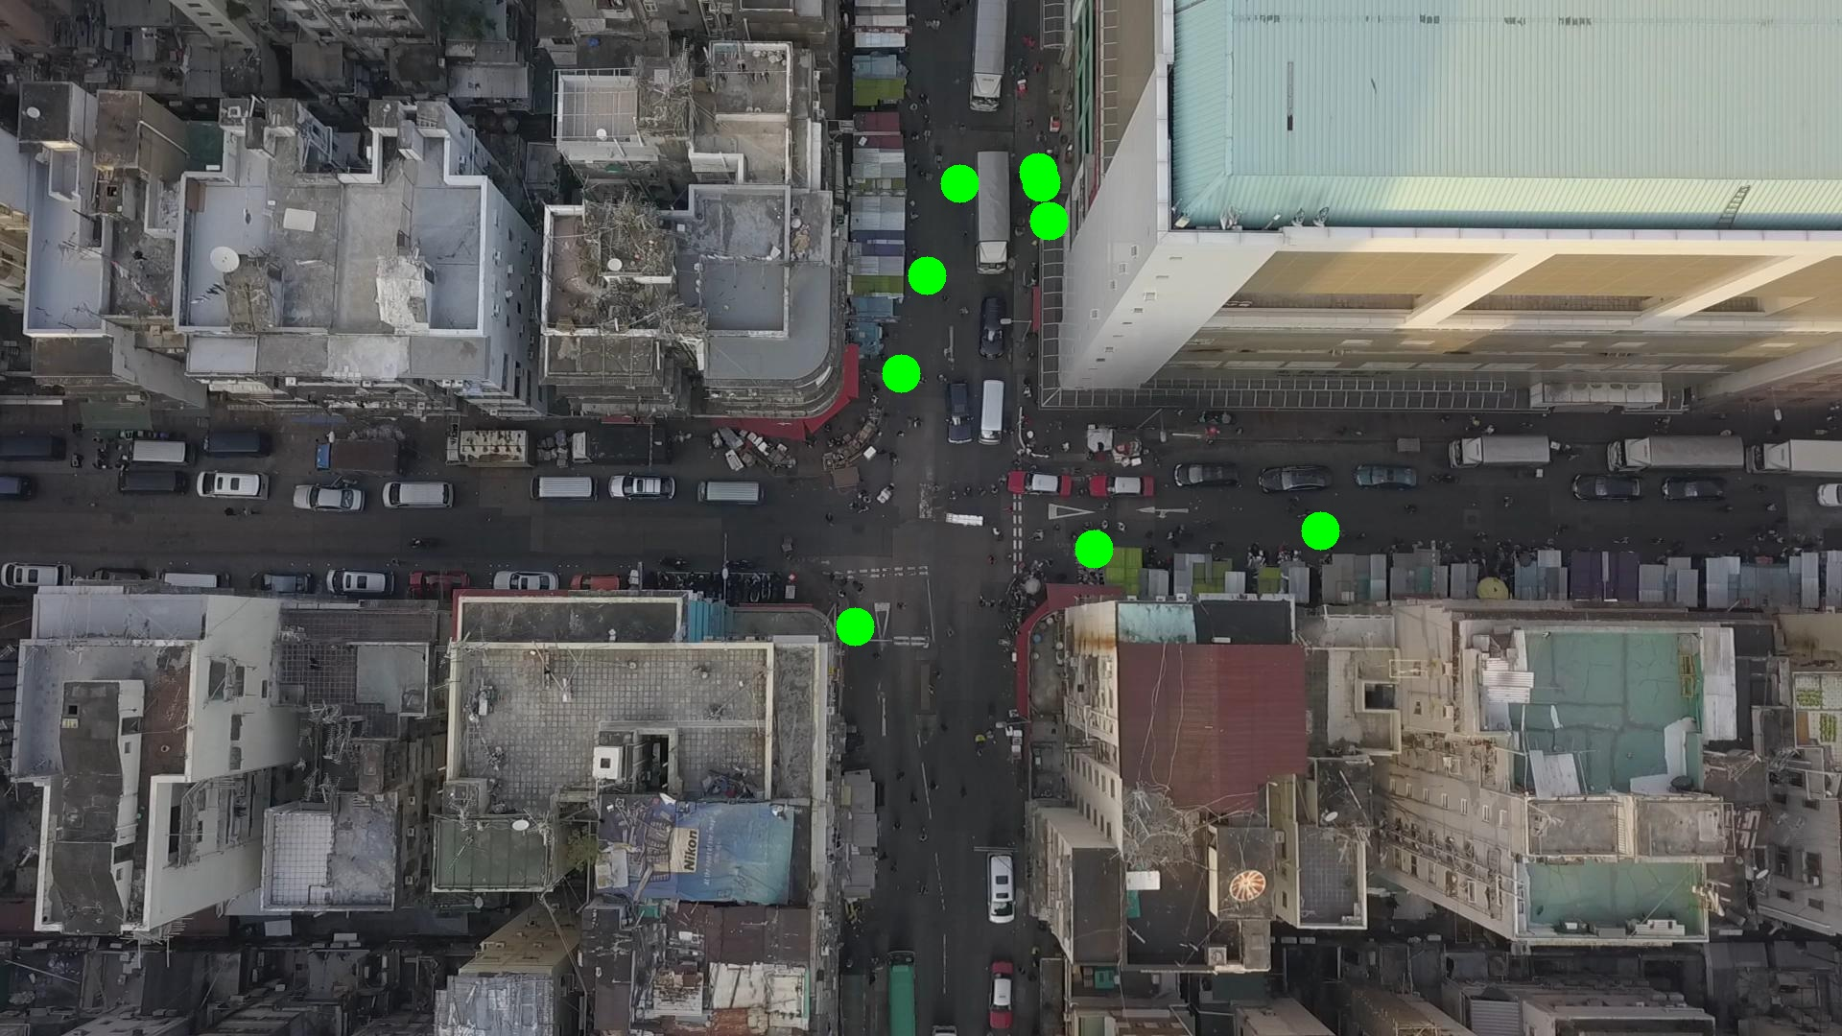

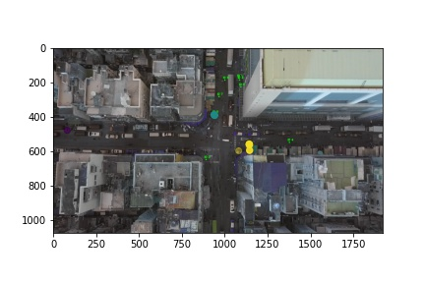

Silhouette metric for img011011.jpg is: 0.8991661267944927

Davies Bouldin metric for img011011.jpg is: 0.48020545309816576

Calinski Harabasz metric for img011011.jpg is: 308.87471129923256

ID 0: (1093, 230)

ID 1: (1082, 179)

ID 2: (1085, 190)

ID 3: (891, 653)

ID 4: (1376, 553)

ID 5: (1138, 559)

ID 6: (929, 394)

ID 7: (966, 284)

ID 8: (1000, 191)

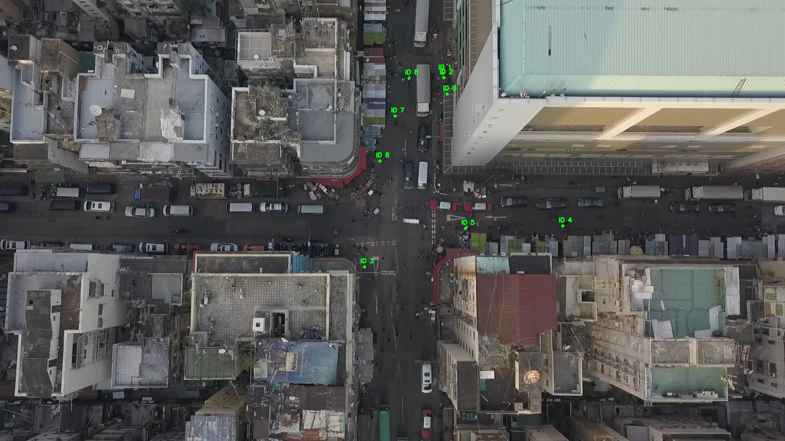

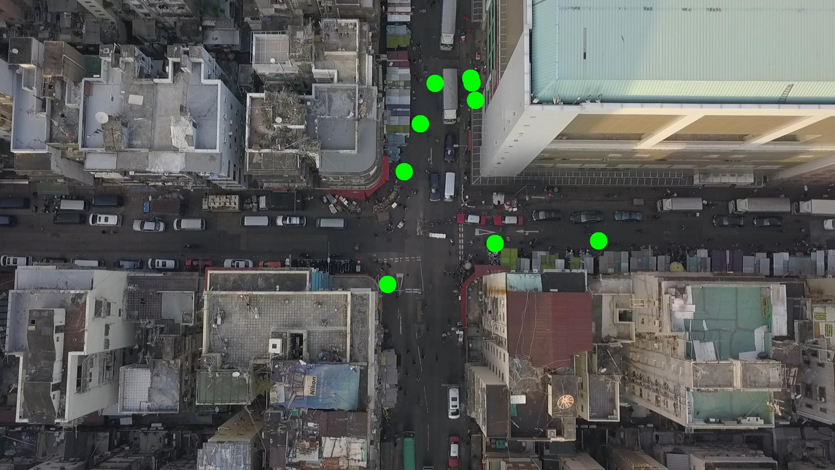

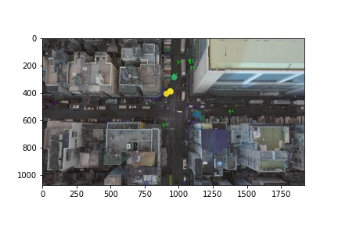

Silhouette metric for img011012.jpg is: 0.9678914701847835

Davies Bouldin metric for img011012.jpg is: 0.037913813209875837

Calinski Harabasz metric for img011012.jpg is: 57175.457942197536

ID 0: (1093, 230)

ID 1: (1085, 141)

ID 2: (1085, 190)

ID 3: (891, 653)

ID 4: (1376, 553)

ID 5: (1132, 560)

ID 6: (938, 389)

ID 7: (966, 283)

ID 8: (1000, 191)

